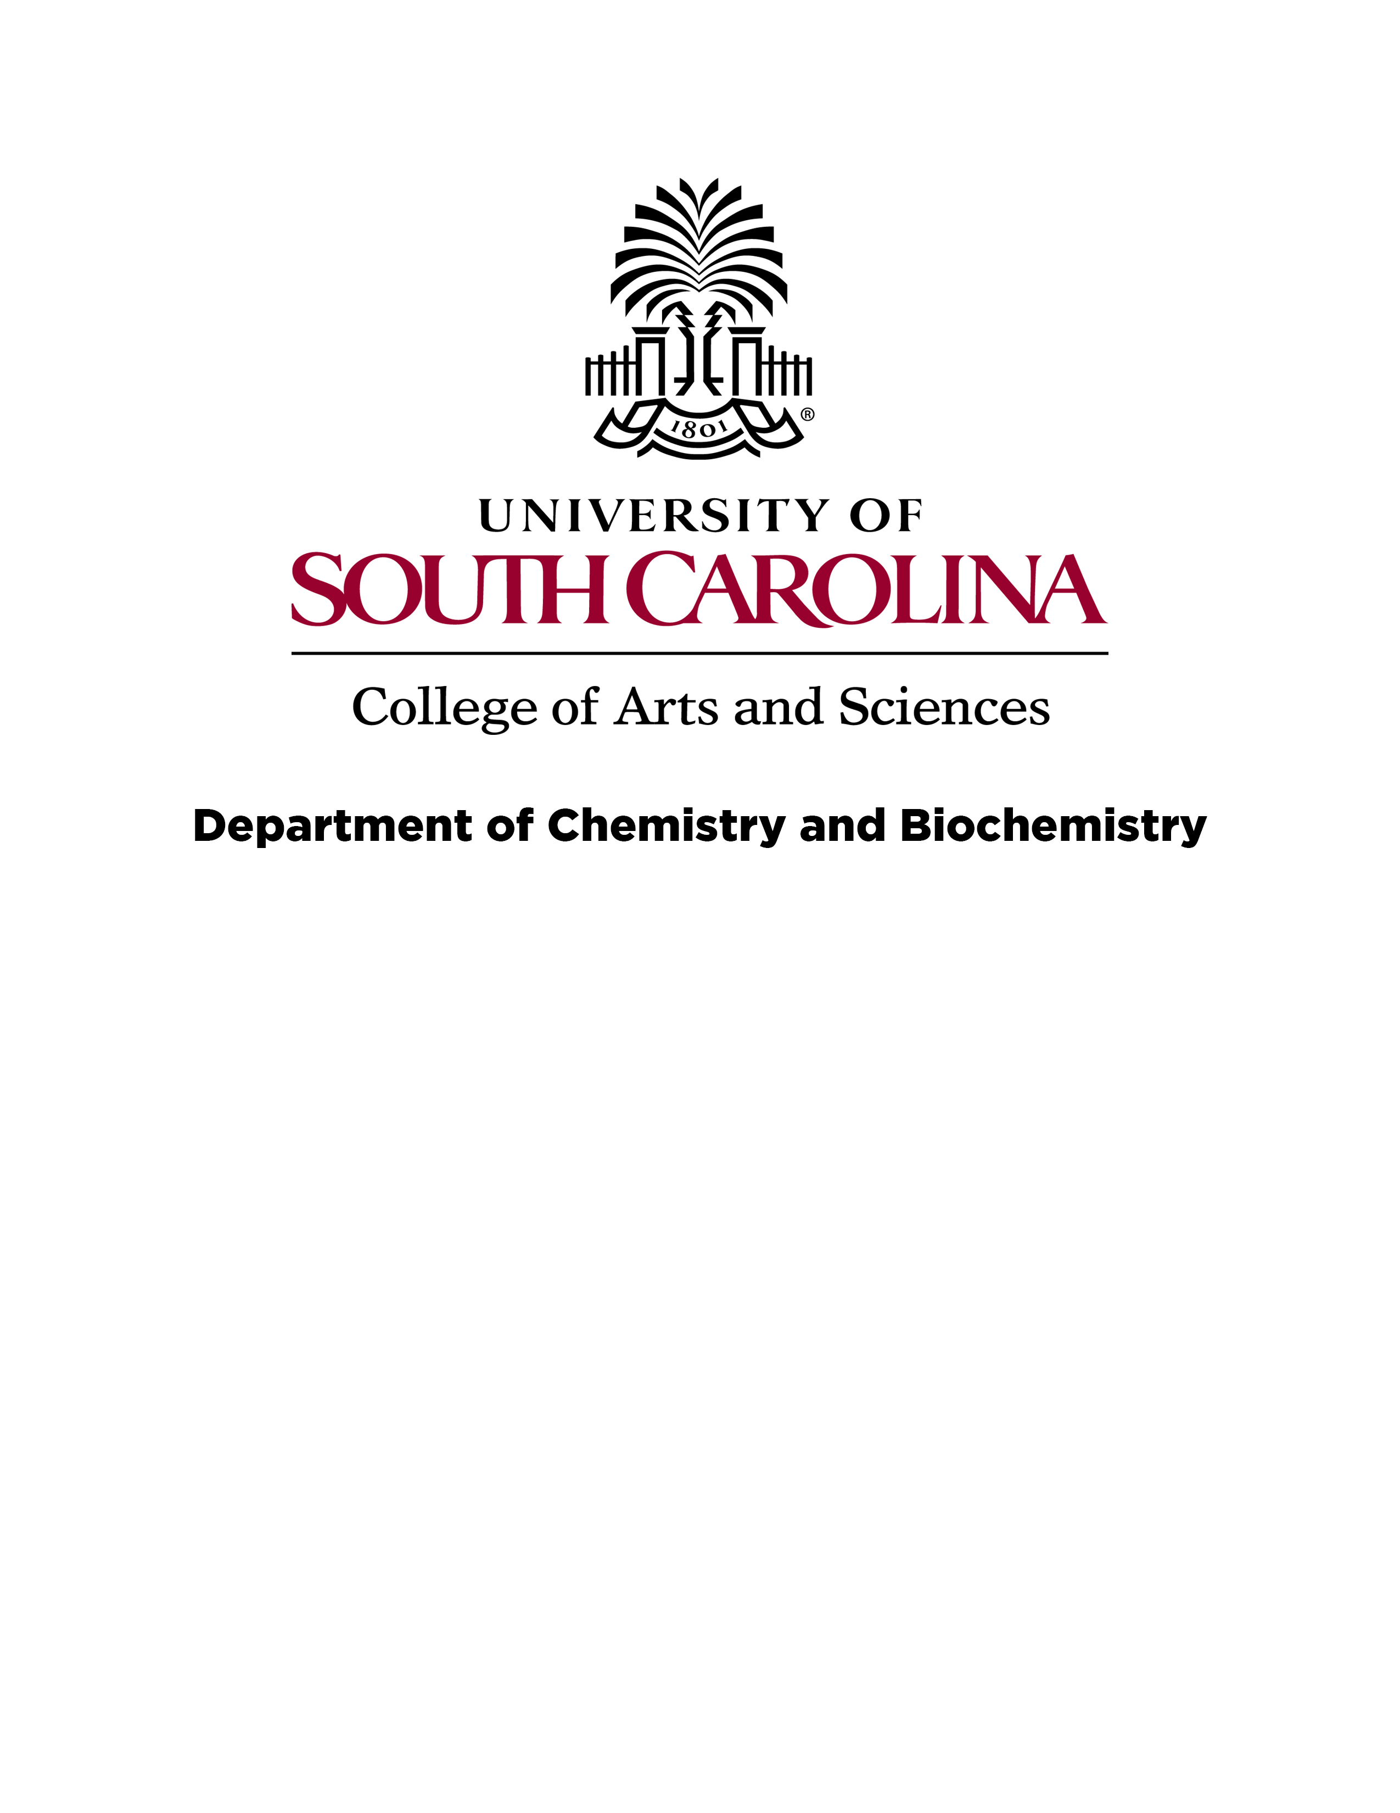

Department of Chemistry and Biochemistry

Memo

To: The Graduate School
From:
Thesis Advisor:
 | ^{Print} |  | ^{Signature}
Graduate Director:
 | ^{Print} |  | ^{Signature}

Re: dissertation embargo request for:
^{Dissertation title}

By:
^{Print} |  | ^{Signature} |  | ^{USCID}
Date:

Please embargo this work until [date] (up to 2 years from date of graduation). This work will be submitted for publication (or, presentation, or for copyright, or for patent applications, etc.) and the peer review process will delay receiving appropriate credit for the work. This embargo will ensure proper credit to the student and faculty working on this important contribution to our field.

